ReactJS Hands-on 12 - Ticket Booking App (Conditional Rendering)

Commands Used
- npx create-react-app ticketbookingapp
- cd ticketbookingapp
- npm start

Project Structure

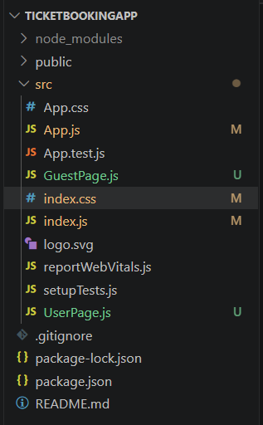

App.js
import React,{Component} from "react";
import GuestPage from "./GuestPage";
import UserPage from "./UserPage";
class App extends Component{constructor(){super();this.state={isLoggedIn:false};}login=()=>this.setState({isLoggedIn:true});logout=()=>this.setState({isLoggedIn:false});render(){return(<div style={{margin:"30px"}}><h1>Ticket Booking App</h1>{this.state.isLoggedIn?(<div><button onClick={this.logout}>Logout</button><UserPage/></div>):(<div><button onClick={this.login}>Login</button><GuestPage/></div>)}</div>);}}export default App;

GuestPage.js
import React from "react";
export default function GuestPage(){return(<div><h2>Welcome Guest</h2><h3>Flight Details</h3><table border="1" cellPadding="10"><thead><tr><th>Flight</th><th>From</th><th>To</th><th>Time</th></tr></thead><tbody><tr><td>AI101</td><td>Hyderabad</td><td>Delhi</td><td>10:00 AM</td></tr><tr><td>AI202</td><td>Chennai</td><td>Mumbai</td><td>2:30 PM</td></tr></tbody></table><p>Please login to book tickets.</p></div>);}

UserPage.js
import React from "react";
export default function UserPage(){return(<div><h2>Welcome User</h2><h3>Book Your Tickets</h3><table border="1" cellPadding="10"><thead><tr><th>Flight</th><th>From</th><th>To</th><th>Time</th></tr></thead><tbody><tr><td>AI101</td><td>Hyderabad</td><td>Delhi</td><td>10:00 AM</td></tr><tr><td>AI202</td><td>Chennai</td><td>Mumbai</td><td>2:30 PM</td></tr></tbody></table><button style={{marginTop:"20px"}}>Book Ticket</button></div>);}

index.js
import React from "react";
import ReactDOM from "react-dom/client";
import "./index.css";
import App from "./App";
const root=ReactDOM.createRoot(document.getElementById("root"));
root.render(<React.StrictMode><App/></React.StrictMode>);

index.css
body{
font-family:Arial;
margin:30px;
}
button{margin-bottom:20px;}

Output
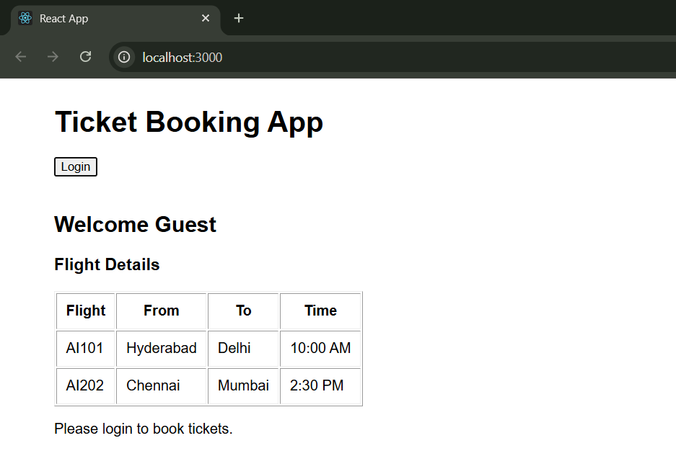
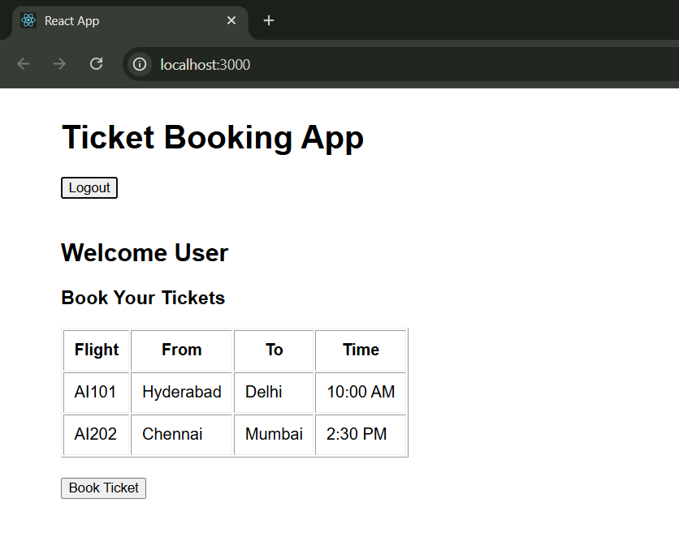

Conclusion
The application successfully demonstrates conditional rendering using React state.

